**Hack-n-Code 2.0 PROJECT**

**Project Life**

**(TEAM ID: 121)**

By

Sarvesh Shinde (HNC122)

Rohit Choudhari (HNC123)

Mihir Desai (HNC124)

October 7, 2018

**Project Details**

**Institution**: SVKM’s NMIMS Mukesh Patel School of Technology Management & Engineering

**Duration**: 12 hours

**Start Time**: 09:00 a.m.

**Submission Time**: 09:00 p.m.

**Title of the Project**: Project Life

**Name**: Sarvesh Shinde

**Team members**:

Rohit Choudhary

Mihir Desai

**Key Words**: Suicide Prevention, Motivation, Immediate Help, Positivity

**Project Areas**:

The areas of the project are as follows:

**Project Development**: Android, Website

**Frontend:** XML (Android), HTML (Website), CSS (Website)

**Backend**: SQLite (Android), JavaScript (Website)

**Abstract**:

Project Life is a multi-platform application based on helping people who are suicidal or have mental issues by showing them new avenues in life. Project Life focuses on reigniting the spark of people by introducing them to new activities every day. Our work is based on the foundation and belief that suicide is preventable and everyone has a role to play in preventing suicide. Through raising public awareness, educating communities, and equipping every person with the right tools, we know we can save lives.

In contrast to clinical approaches that explore the history and health conditions leading the individual committing suicide, the public health approach to suicide prevention focuses on identifying broader patterns of suicide and suicidal behaviour throughout a group or population.

Project Life focuses on day to day life of the affected person, establishing new goals, using powerful quotes to generate positive thoughts.

**TABLE OF CONTENTS**

|  |  |
| --- | --- |
| **SNo.** | **Title** |
| ***I*** | ***Acknowledgement*** |
| ***II*** | ***Abstract*** |
| ***III*** | ***Introduction*** |
| **1** | **Project Development** |
| 1.1 | The Basics |
| 1.2 | Specifications |
| **2.** | **Setting Up The Project** |
| 2.1 | *Any specific instructions the jury should know while testing the project for setup* |
| 2.2 | *Unique Functionalities* |
| 2.3 | Screenshots of the working model with process flow and code snippets |
| **3.** | **Developing The Project** |
| 3.1 | User Interface |
| 3.2 | Build Dependencies |
| **4.** | **Testing** |
| **5.** | **Technologies Used** |
| **6.** | **Future scope** |
| ***VII*** | ***Conclusions*** |
| ***VIII*** | ***References*** |

I. **Acknowledgement**

We would like to thank IET MPSTME On Campus for organising the Hackathon adeptly. And also, to Hackerearth as the platform made the experience of submission not only painless but also joyful.

II **Abstract**

Project Life is a multi-platform application based on helping people who are suicidal or have mental issues by showing them new avenues in life. Project Life focuses on reigniting the spark of people by introducing them to new activities every day. Our work is based on the foundation and belief that suicide is preventable and everyone has a role to play in preventing suicide. Through raising public awareness, educating communities, and equipping every person with the right tools, we know we can save lives.

In contrast to clinical approaches that explore the history and health conditions leading to suicide in the individual, the public health approach to suicide prevention focuses on identifying broader patterns of suicide and suicidal behaviour throughout a group or population.

Project Life focuses on day to day life of the affected person, establishing new goals, using powerful quotes to generate positive thoughts.

III **Introduction**

Project Life is an Android Application at heart suited for easy access when a person feels depressed or down. The homepage is curated everyday for new and cheerful content so, the user has new activities and music to look forward to everyday.

Project Life tries to encourage the user’s independence by suggesting activities he/she can accomplish by himself. Thus, giving him/her a sense of pride and accomplishment. Project Life banks on developing these qualities of the user and boosting his self-confidence.

**1. Project Development**

**1.1 The Basics**

We developed an Android Application which acts as a base of our interaction and for setting goals. The application handles the data of the user as a standalone entity. The website gives an adequate gist of all the resources to any user without a logging requirement.

**1.2 Specifications**

Android Application

Base Version: Android 7.0 (Nougat)

SDK Requirement: 24

Size: 5 mb

Usage Complexity: Low

Setup Difficulty: Minimal

Website

Frontend: HTML & CSS

Backend: JavaScript

Usage Complexity: Low

Setup Difficulty: None

**2. Setting up the Project**

Android Application:

Open the project using android studio and install it on any phone with or above Android Version 7.0 Nougat.

Website:

Download the files and open index.html to access the website.

Or visit http://project-life.github.io

**3. Developing the Project**

**3.1 User Interfaces**

Android App:

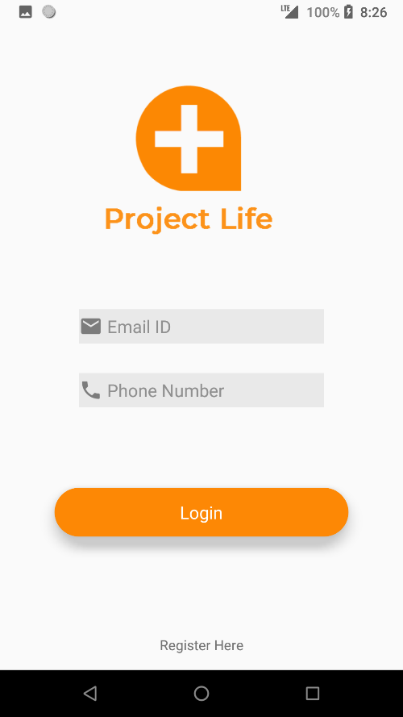 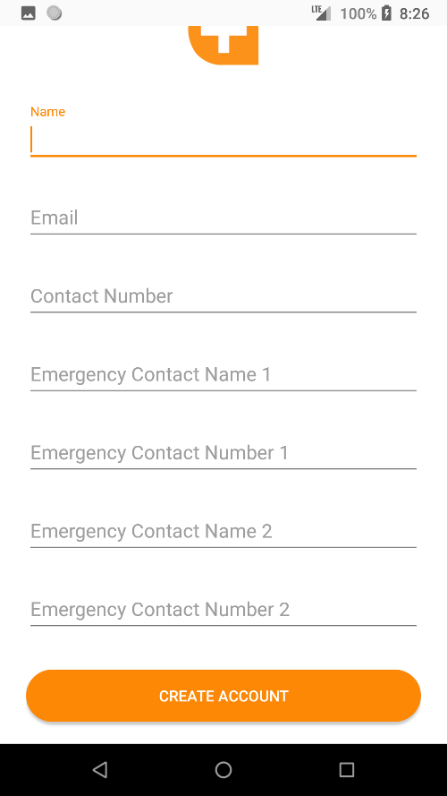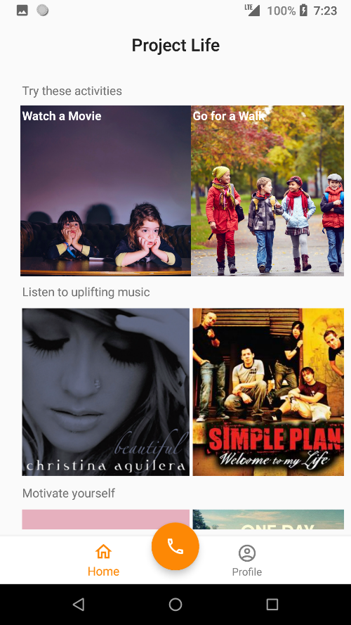 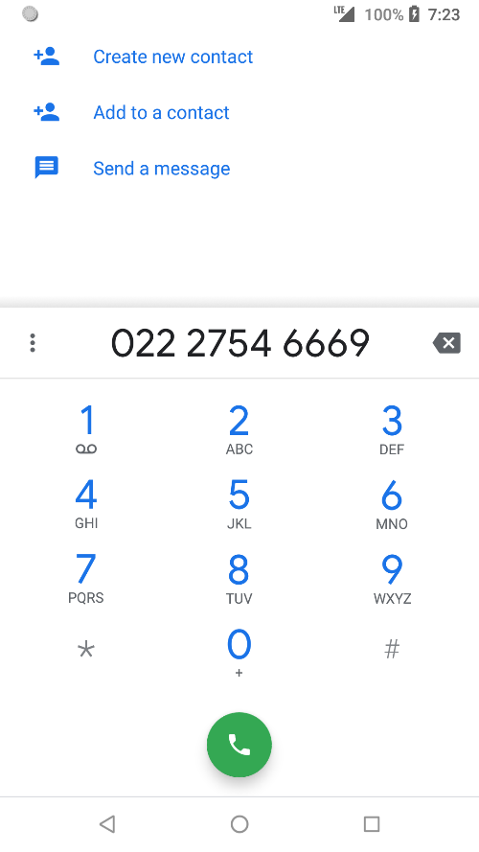 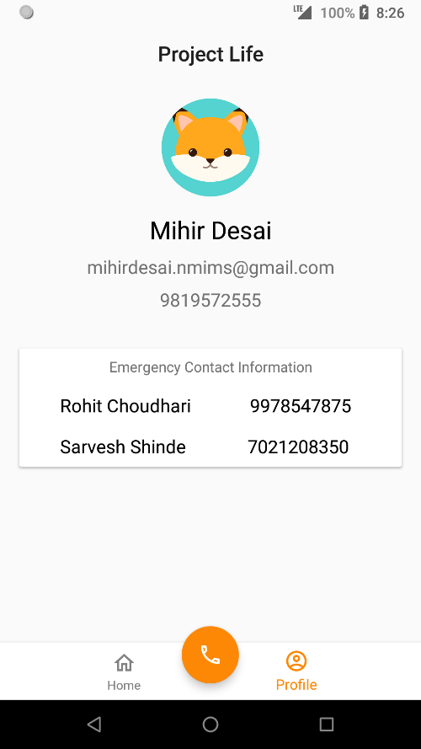

Flow of the Application:

1. Registration
2. Login
3. Profile Page
4. Home Page
5. Call Help

**Website:**

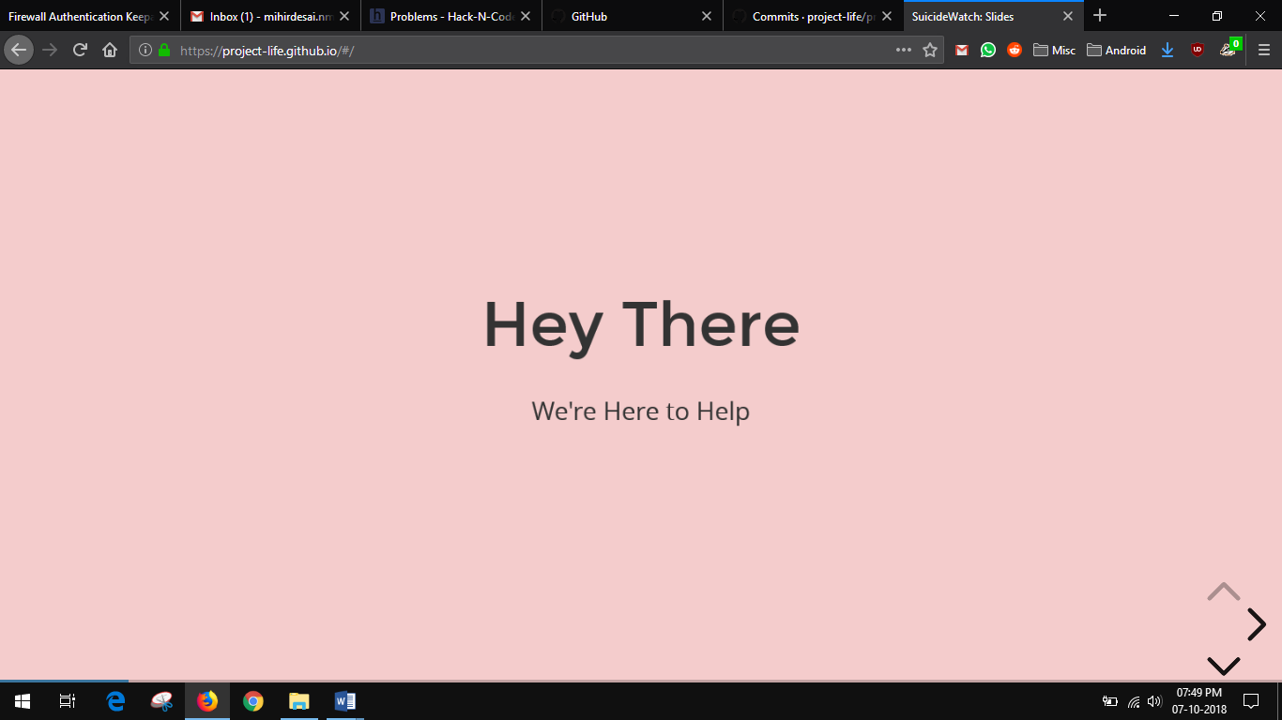

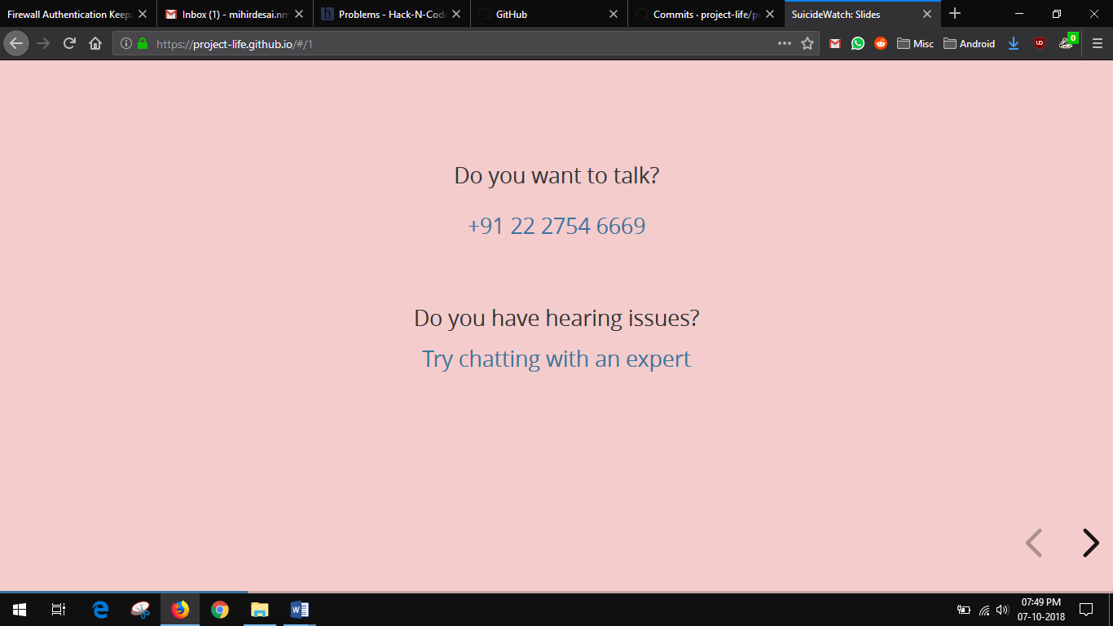

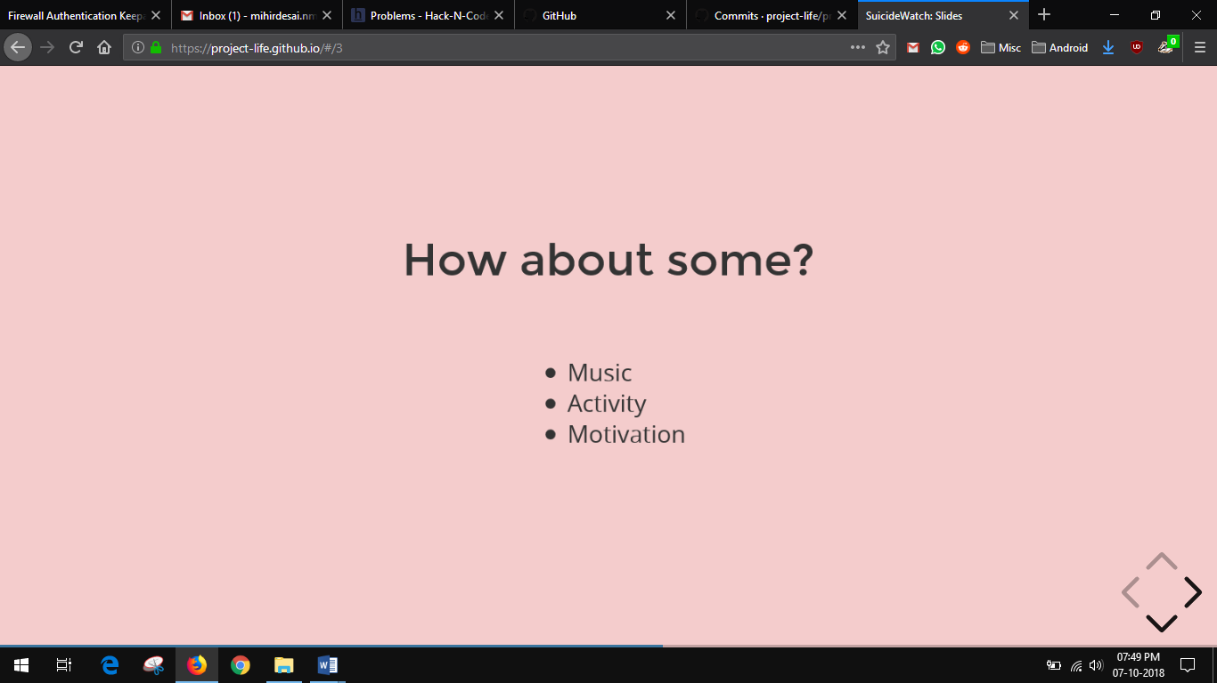

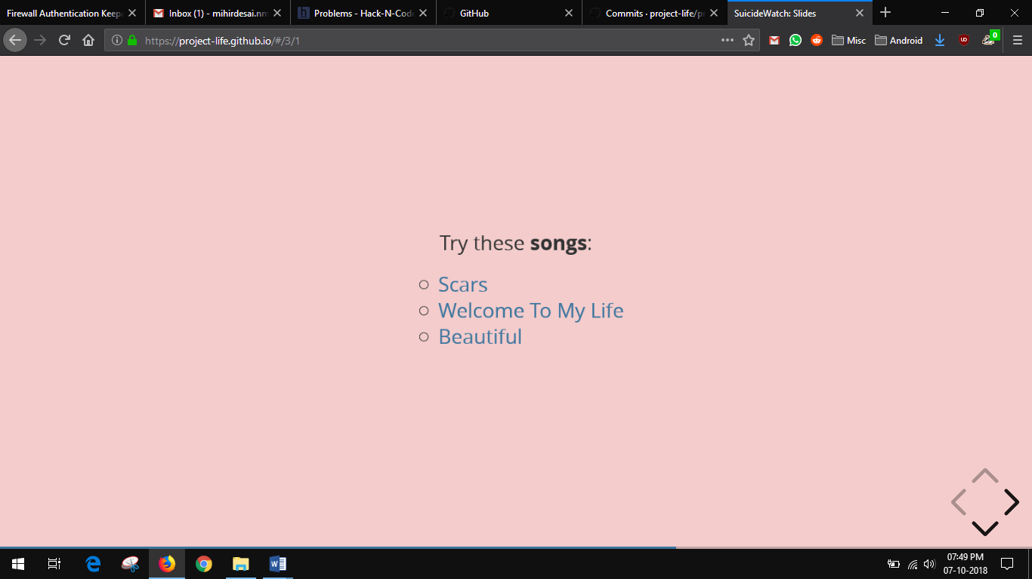

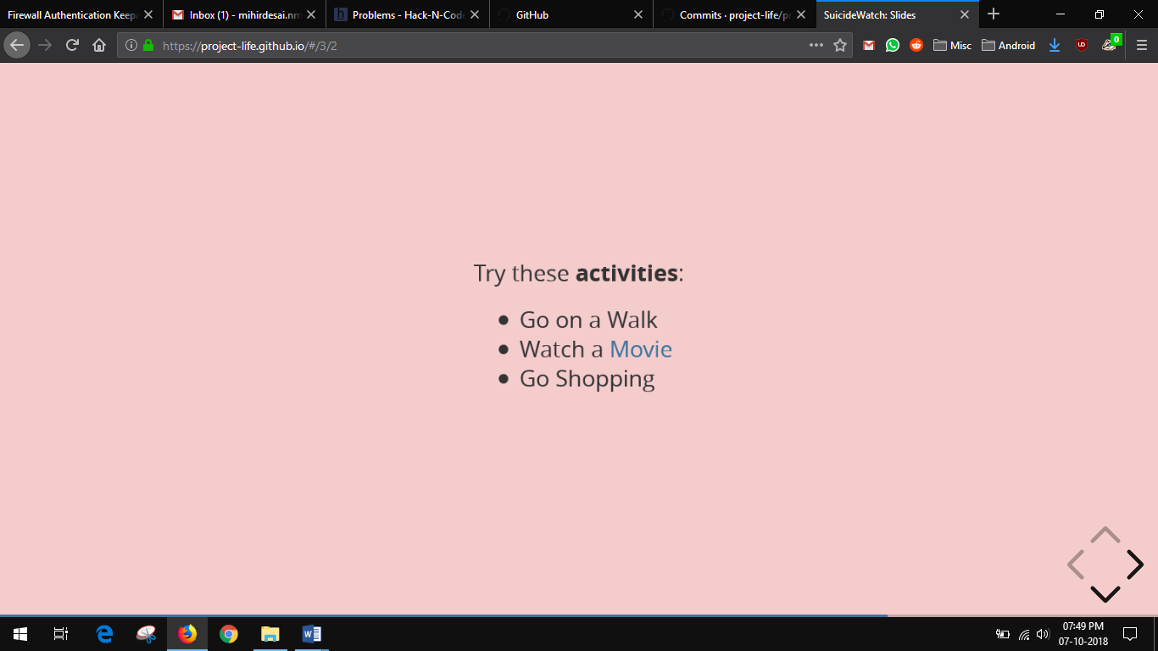

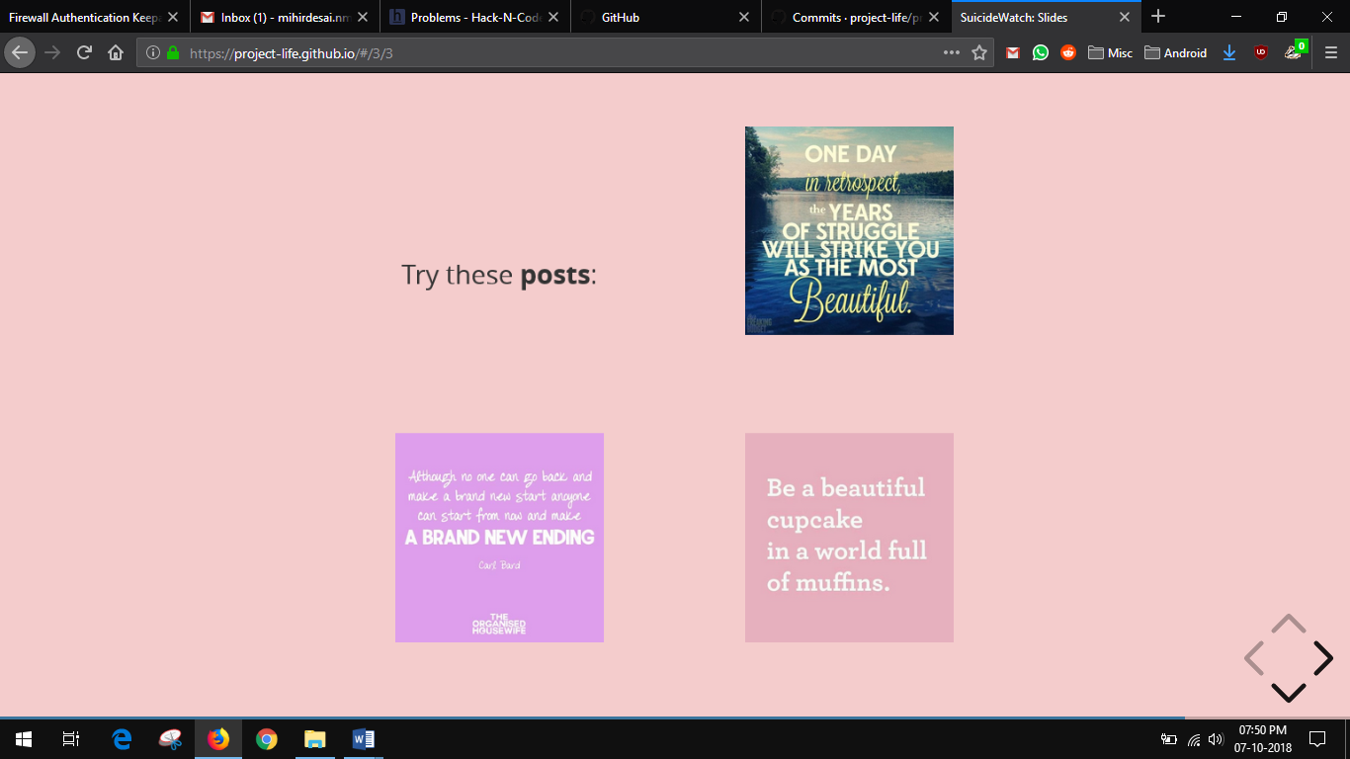

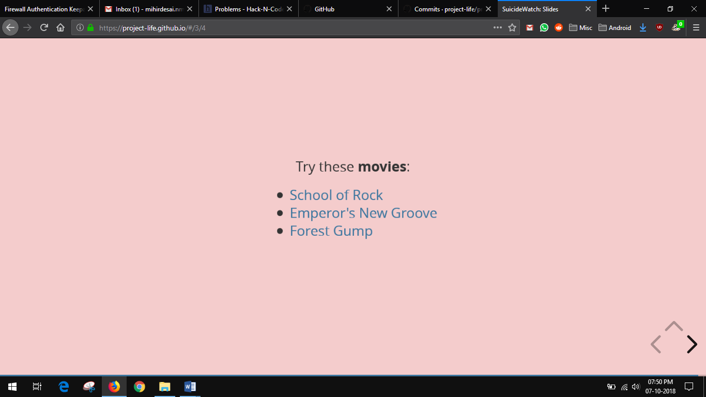

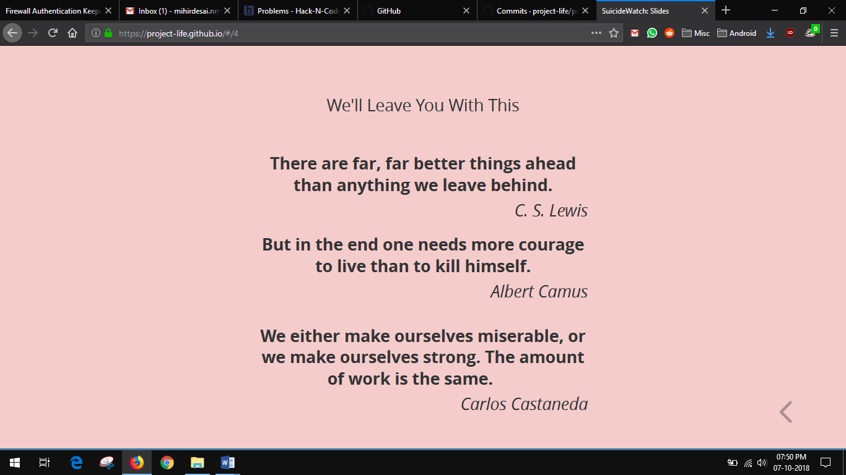

**3.2 Build Dependencies**

**4. Testing**

Android Application

Devices tested upon: Redmi Y1, Nexus 5X, One Plus 3T

Website

Browsers: Mozilla Firefox v62, Google Chrome v69, Microsoft Edge v42

**5. Technologies Used**

Android Studio used for developing Android Application

Sublime Text used to create the website.

**6. Future Scope**

We aspire to deploy this application to the end users by establishing a strong backend network. Modifications we would like to make in the final release:

* Platform Login
* Community Interaction Program
* Support Group Integration
* Instant Messaging Functionality

**VII Conclusions**

Tackling mental health problems requires a range of approaches and some innovation in service delivery. This will require industry, government, mental health groups and service users to work together to find appropriate solutions for those with differing mental health problems and needs. The use of technology to deliver mental health services is one area of particular interest and is being explored in more detail by the government. The overall aim is helping people get access to the mix of services they need, while also helping them get back to or stay in work.

While developing Project Life we realised the multitude of mistakes that a person can do while tackling such issues and also how some useful platforms get buried in the flurry of misinformation.

So, Project Life aims to deal with this problem by making the flow more community driven so the people can look out of other people while looking out for themselves.

**VIII References**

We analysed various studies on the subject before curating our application. Here are the major ones:

* <https://jamanetwork.com/journals/jamapsychiatry/article-abstract/494730>
* <https://www.bmj.com/content/322/7289/789.short>
* <https://bmcpsychiatry.biomedcentral.com/articles/10.1186/1471-244X-10-113>
* <https://www.ncbi.nlm.nih.gov/books/NBK524967/>